Host: Sabaneta Women’s Club
Experience: Homestay Assignment

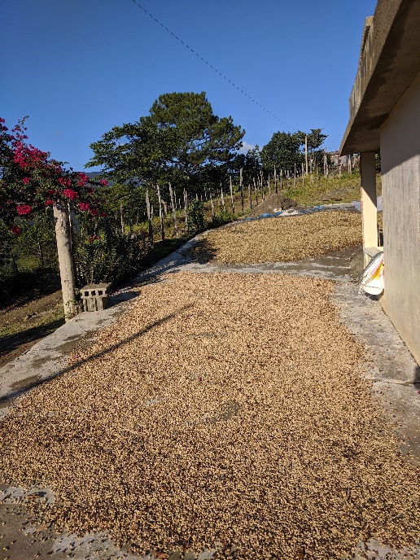
As you can imagine, some of our assignments take place in very vulnerable communities: rural settlements that are far away from large cities and mechanized agricultural processes. This is exactly the case of the community of Sabaneta, in the heart of the Central Mountain range of the Dominican Republic. The Sabaneta women’s club, formed by 12 FARMERS? Has already received three volunteers that focused on strawberry production, added value products and agro/ecotourism. Being four hours away from the capital, Santo Domingo, and only reachable by 4x4 vehicles, the volunteers that participate in Sabaneta’s Adventure are able to enjoy one of the most special parts of volunteering: Homestays.

Volunteers stay at Zeneida and Rafael’s house, a beautiful couple that have lived their entire life in the town, and that are always up for improving the community’s quality of life. Their coffee crops are their livelihood, with some guided tours to Pico Duarte, the highest mountain in the country.
Figure 4. Drying coffee beans scattered around Zeneida and Rafael's house.
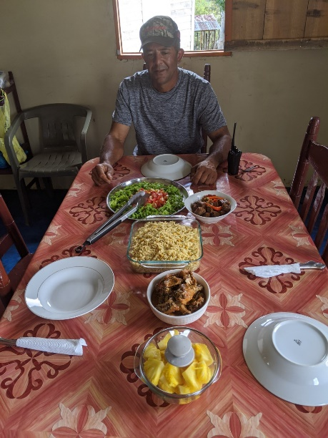
“My host family was so gracious and thoughtful --- they are just a wonderful loving couple --- singing as they worked, both husband and wife helping with not just the work, but with household chores together as well and when the day was done. I would watch the wife sit in her husband’s lap and chat with us about the day --- a real difference from the stressed out couples trying to climb the corporate ladder in the US. They may seem poor to us monetarily, but they are far wealthier than us in quality of life and happiness.”
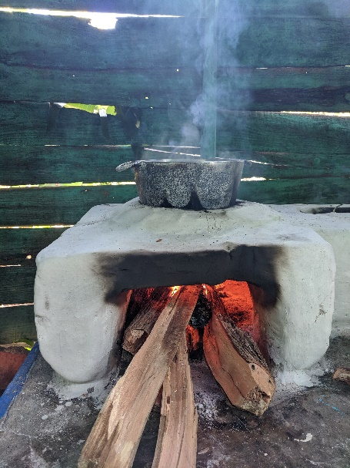
-Volunteer Darren Schmall, Agri/Ecotourism Assignment. November 2019
Figure 5. Rafael sitting at the table before having a real dominican lunch with Zeneida, the volunteer and the field officer.

Homestay assignments really allow the volunteers to relish in the complete rural experience: waking up and going to sleep with the sun, limited phone and internet access, enjoying cups of freshly toasted coffee while admiring beautiful views right from the doorstep, and authentic Dominican food cooked in wood stoves.

“They have been wonderful hosts, and shared many of their ideas and challenges. Their home was comfortable, the food was plentiful and delicious, and they were always happy to provide answers to my questions. I have traveled to many countries around the world and have never felt as welcomed, accepted and appreciated as I have felt in the mountain community of Sabaneta. My only hope is that they learned as much from me, as I learned from them!” – Darren Schmall
Figure 6. A dominican woodstove, also called "fogón". The food cooked in it has a particular wood taste. It is seen mostly in rural areas.

Kate Penhallegon, one of our volunteers, wrote this poem about the community of Sabaneta in October 2019:

On the road to Sabaneta
A twisting winding road
We saw guava, lime and coffee trees
Then we hit a hole

Our heads went up, our truck went down
Then we spun all around
On the road to Sabaneta
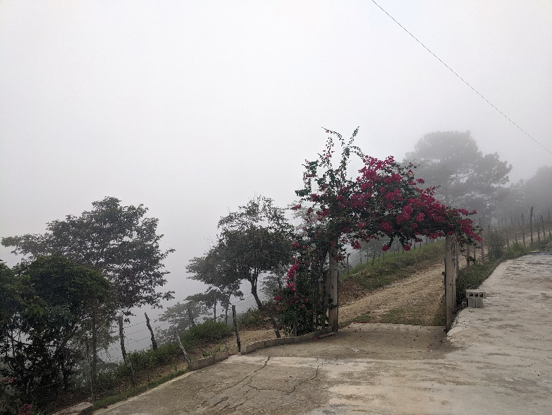
Figure 7. The entrance to Zeneida and Rafael's house on a foggy day.
A ten-mile trip, a one-hour ride
With mountains so high
We went to four-wheel drive and
tried to miss that hole, ….but

Our heads went up, our truck went down
And we spun all around
On the road to Sabaneta

The view was grand, the people few
We felt the peace
And before we knew,
Another darn hole

Our heads went up, our truck went down
And we spun all around
On the road to Sabaneta

When I dream, I'm on that mountain
Hanging with those people
They stole my heart in Sabaneta.

What holes?

We really think these rhymes define the experience,don’t you?

